Figures and Tables for the paper

**Part 1. Tables**

1. **miRNA numbers and its classification**

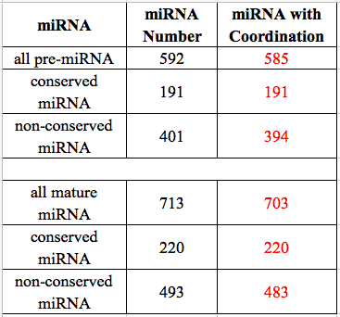

**[Table description]**

All the miRNA info is collected from *miRBase.org*, but not all miRNAs (include pre-miRNAs and mature miRNAs) resided are provided with coordination in the genome. Some of the unprovided miRNAs’ coordination are gained with BLAST.

(There are 592 pre-miRNAs along with 713 mature miRNAs resided in *miRBase.org* in total. And we have collected the coordination of 585 pre-miRNAs and 703 mature miRNAs.

After miRNA classification, 191 of the total pre-miRNAs fall into the category of conserved pre-miRNAs, all of which have coordination info; while the rest pre-miRNAs are non-conserved ones, out of which 394 miRNAs have coordination info. 220 of the total mature miRNAs are conserved miRNAs with their coordination info complete, while 493 of them are non-conserved mature mRNAs, out of which 483 miRNAs have coordination info.)

1. **Target genes of conserved miRNAs obtained**

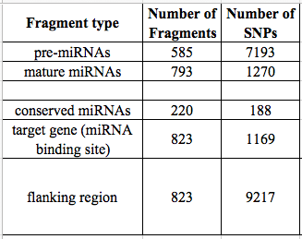

**[Table Description]**

Target genes are only for conserved miRNAs. And the flanking regions are composed of miRNA binding site and its upstream and downstream ~100bp flanking regions.

(We obtain 823 target genes of 220 conserved miRNAs aided by online prediction tools and papers published.

After searching the 3K Rice SNP-Seek Database, we have found abundant SNPs in numerous types of genomic regions in question, including 7193 SNPs in pre-miRNAs, 1270 SNPs in mature miRNAs, 1169 SNPs in miRNA binding sites of the conserved miRNAs. In addition, we have searched SNPs for the ~100bp flanking regions of miRNA binding sites (include the binding sites), and the product is 9217 SNPs in total.)

1. Basic info of combined haplotype patterns

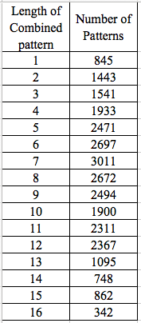

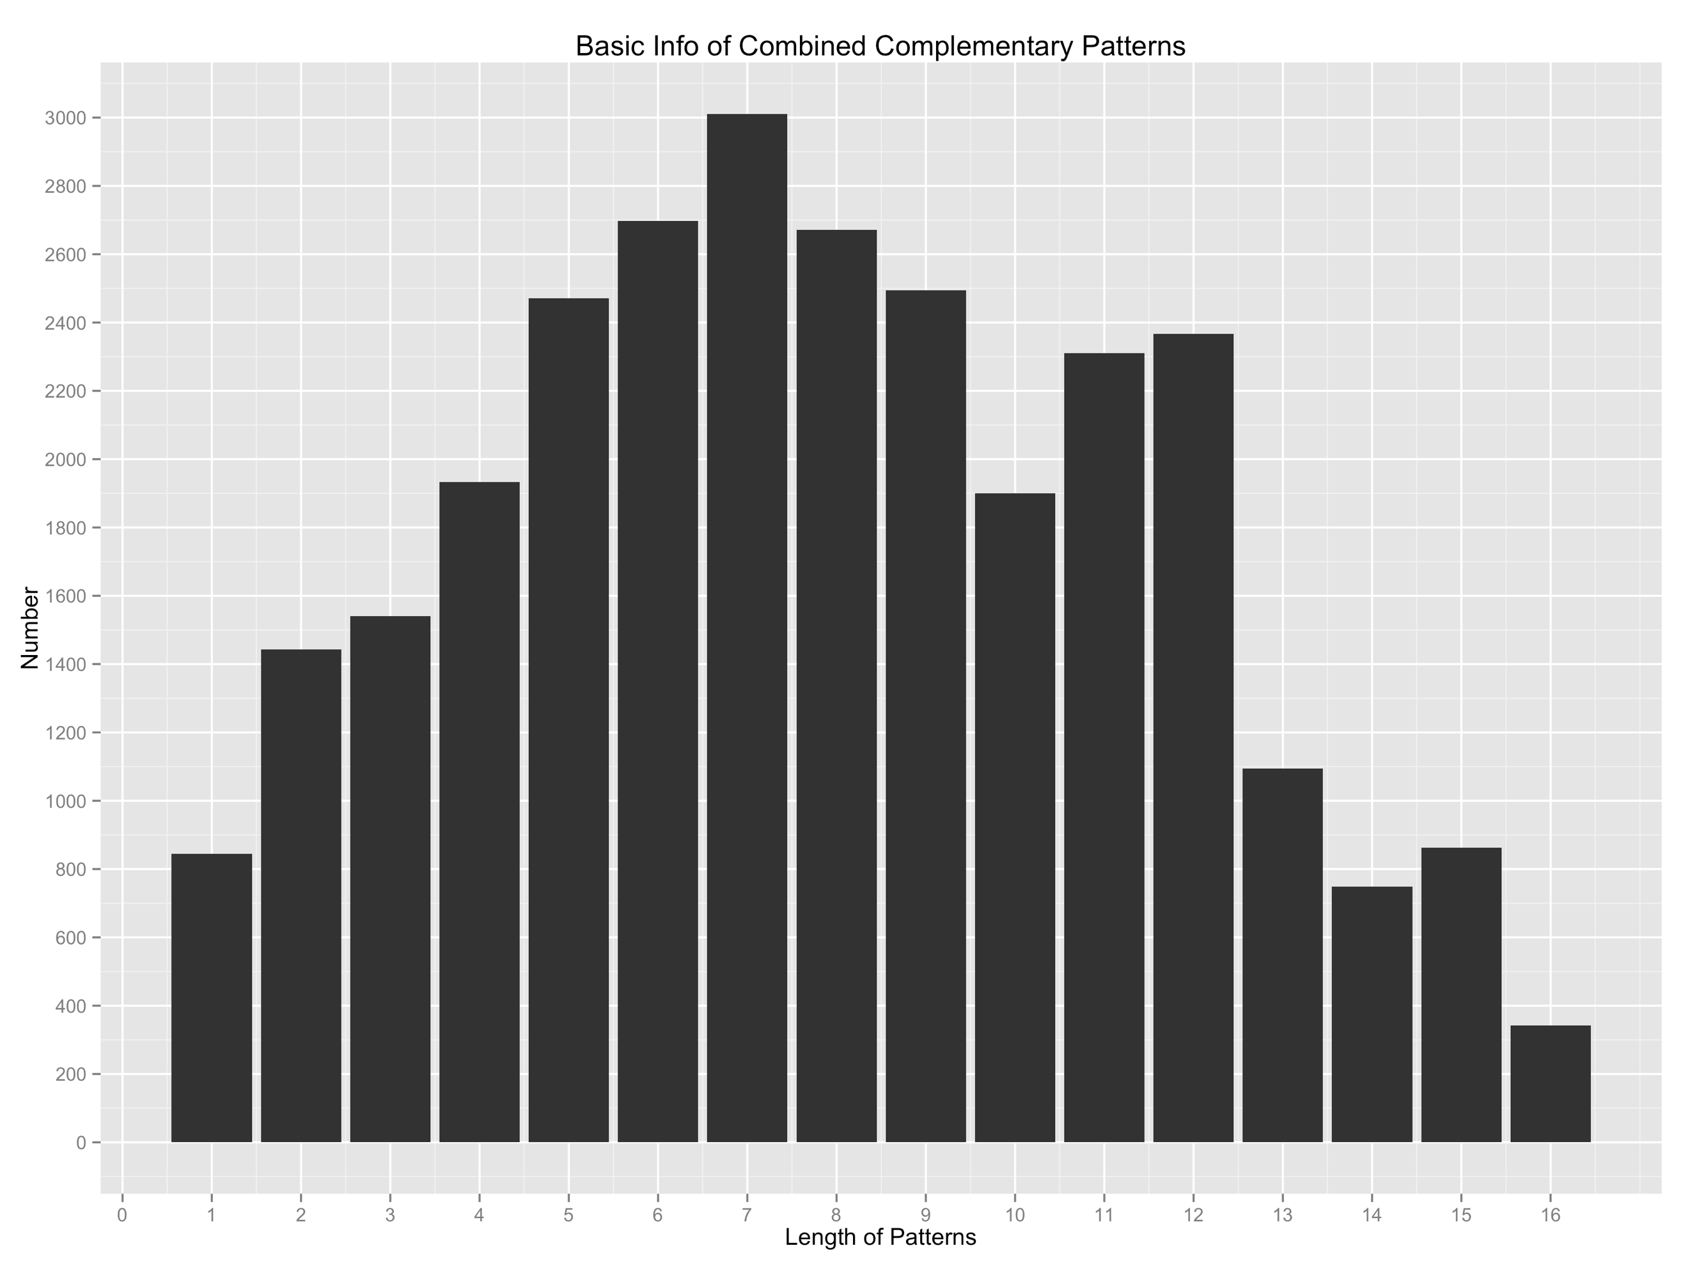

**[Table Description]**

Length of combined pattern stands for the length of patterns of combined haplotype, to wit, the number of SNPs of both mature miRNA and its binding site counterpart.

(We have analyzed 180 miRNAs together with their 538 target genes, and finally we obtained 28732 unique combined haplotype patterns. And length of combined pattern stands for the length of patterns of combined haplotype, to wit, the number of SNPs of both mature miRNA and its binding site counterpart.)

**Part 2. Figures**

1. **SNP distribution figures**
   1. **Mature miRNA SNP distribution**

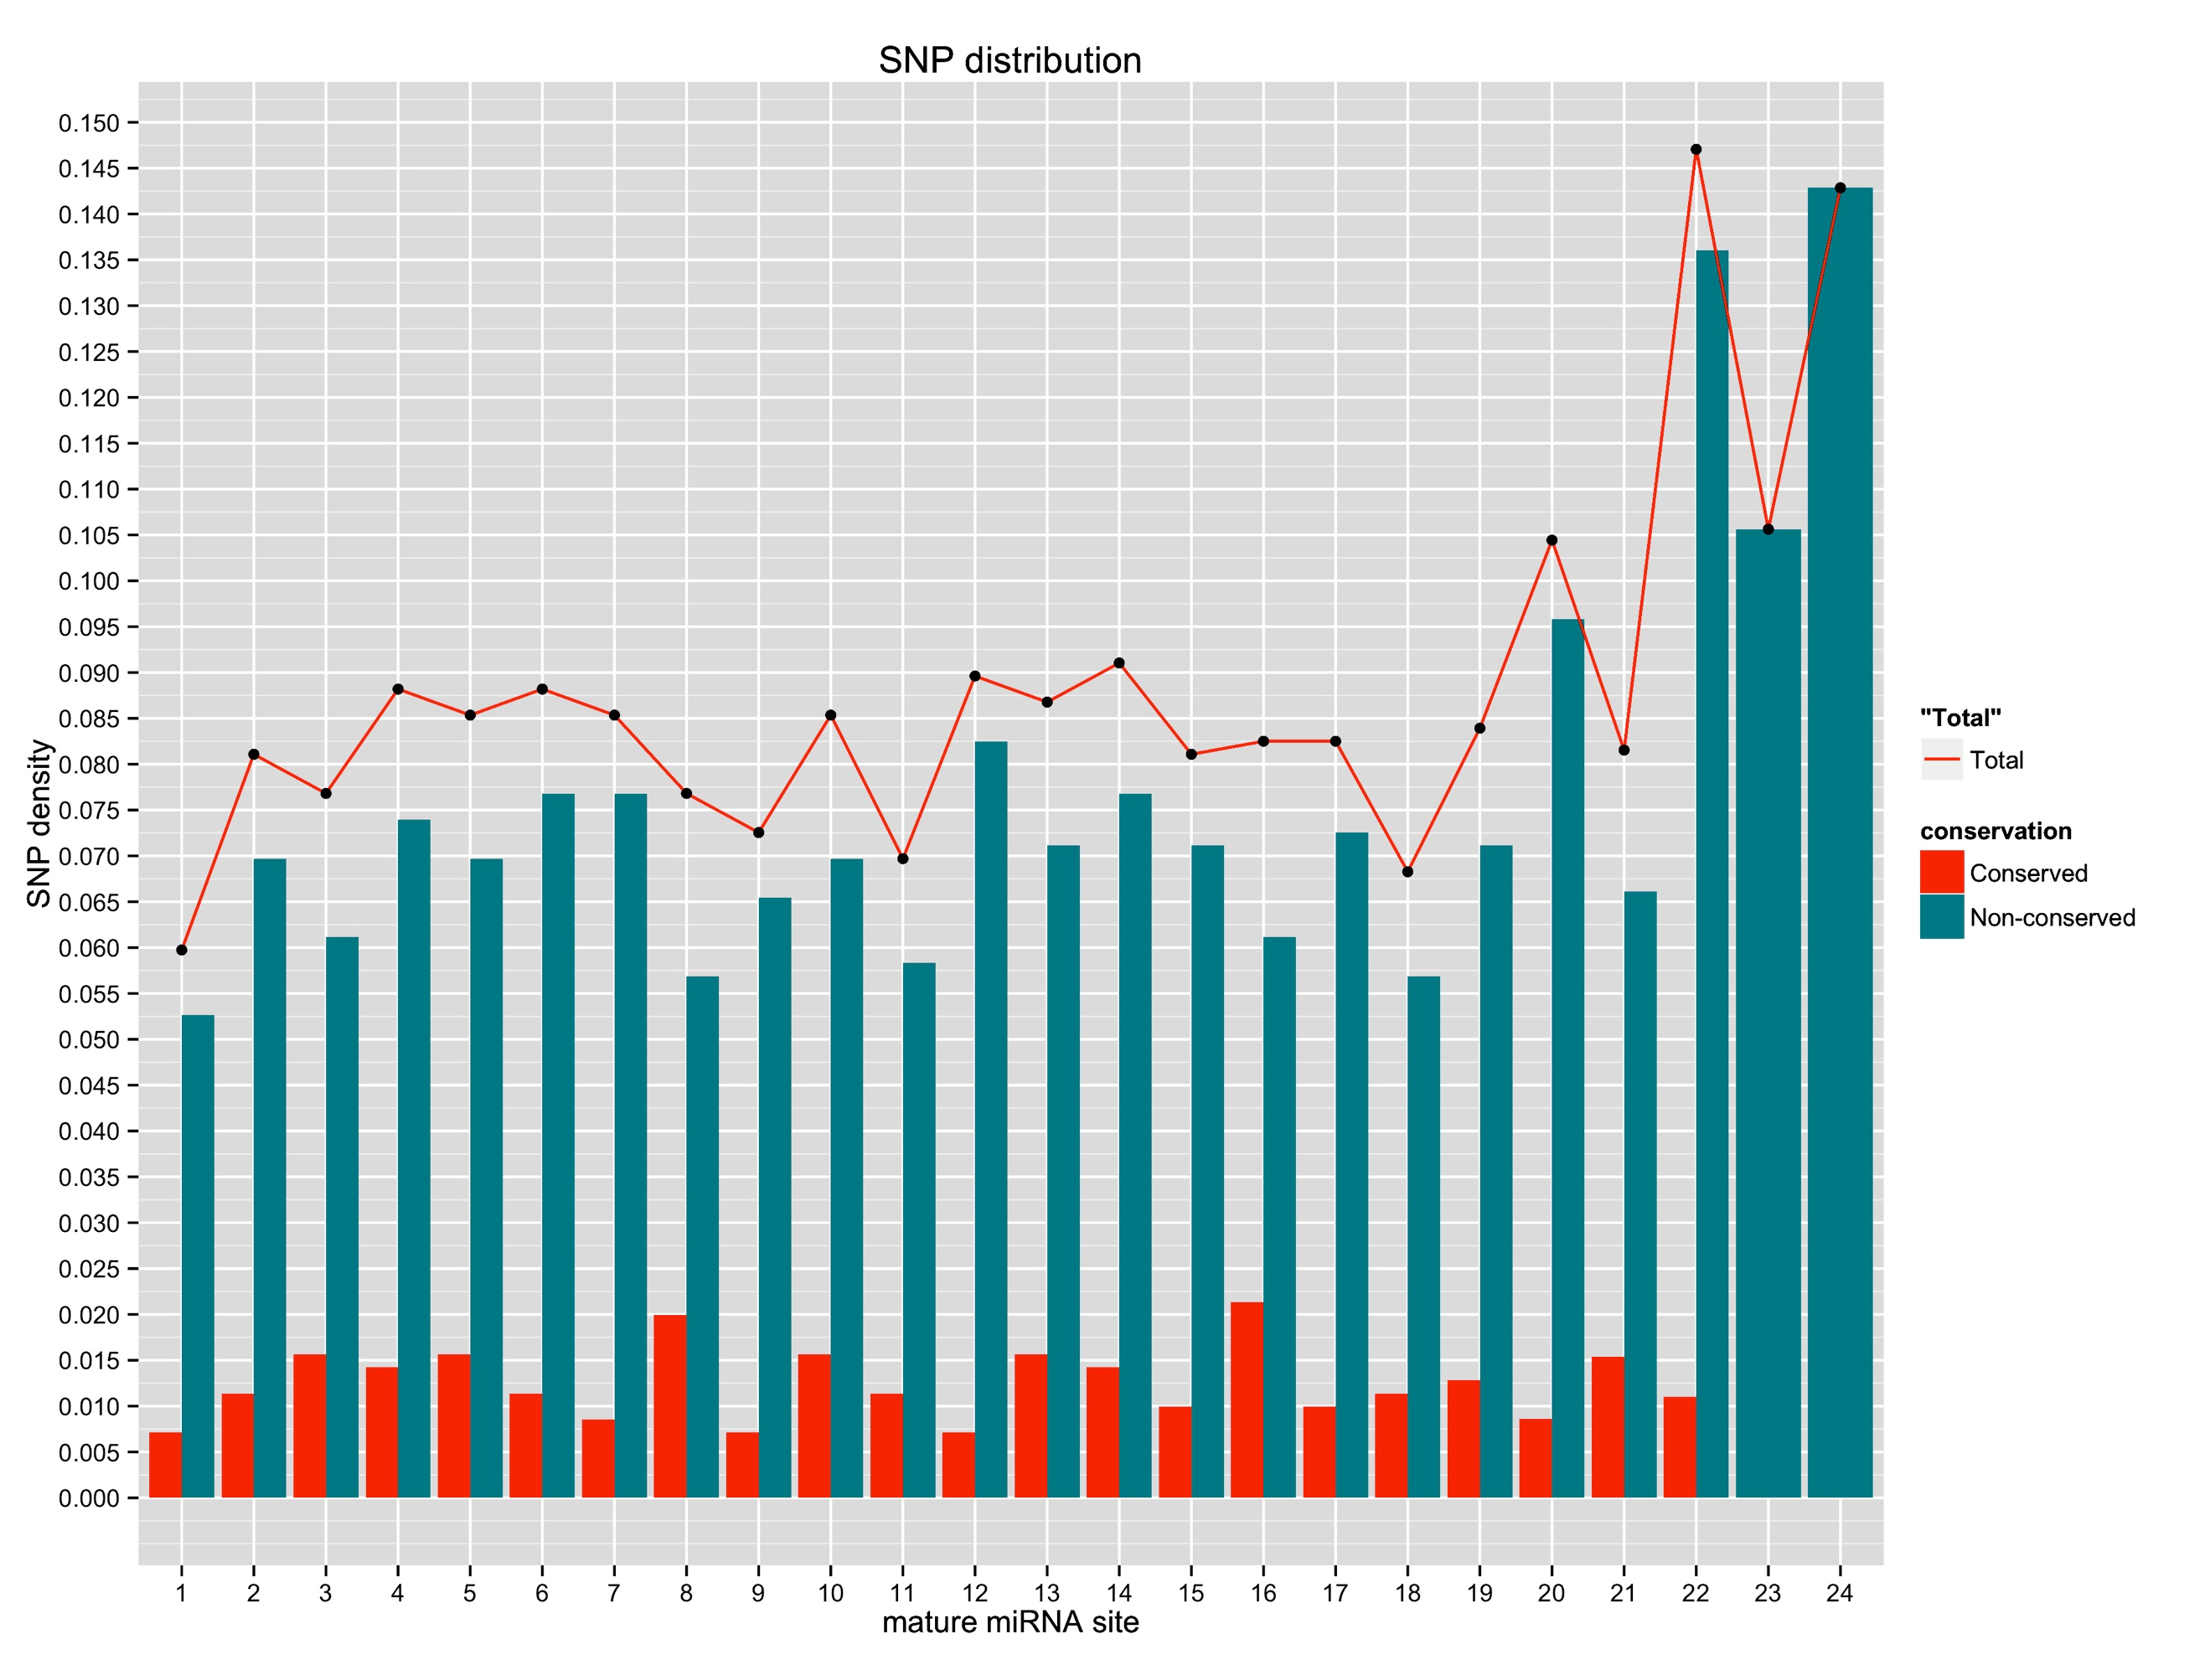

Figure 1. This is the SNP distribution of mature miRNA.

SNP density = (Number of miRNAs possess SNP at the given site) / (Number of miRNAs have the given site);

Mature miRNA site is in the order from 5’-end to 3’-end;

The curve total stands for the SNP density distribution of all miRNAs

* 1. **SNP distribution figure of miRNA binding sites in genes targeted by conserved miRNAs**

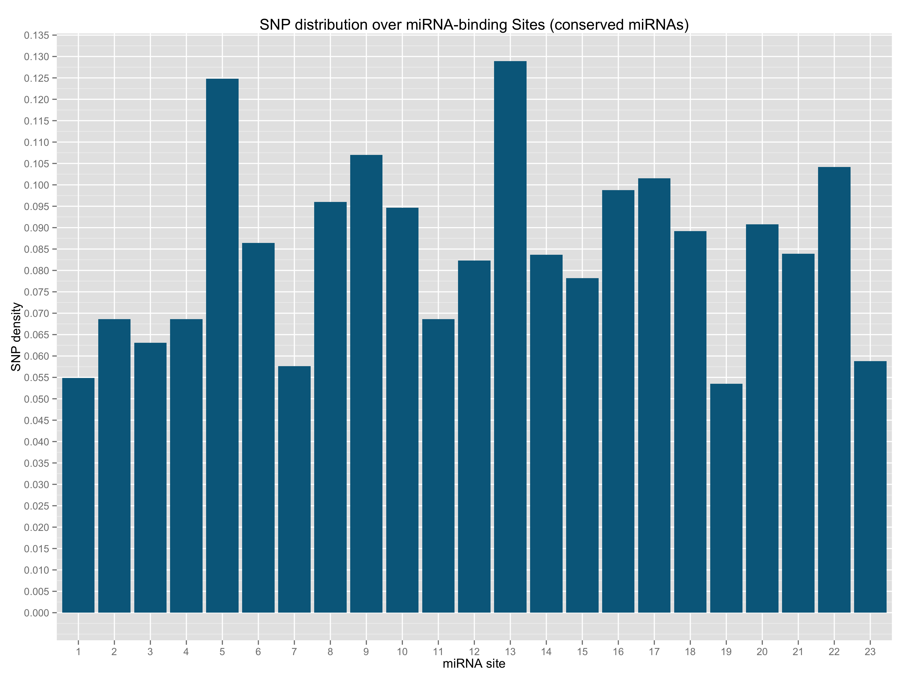

Figure 2a. miRNA site is by the same order as the 5’ - 3’ orientation in its mature miRNA counterpart.

* 1. **SNP distribution figure of miRNA binding sites in genes validated by degradome**

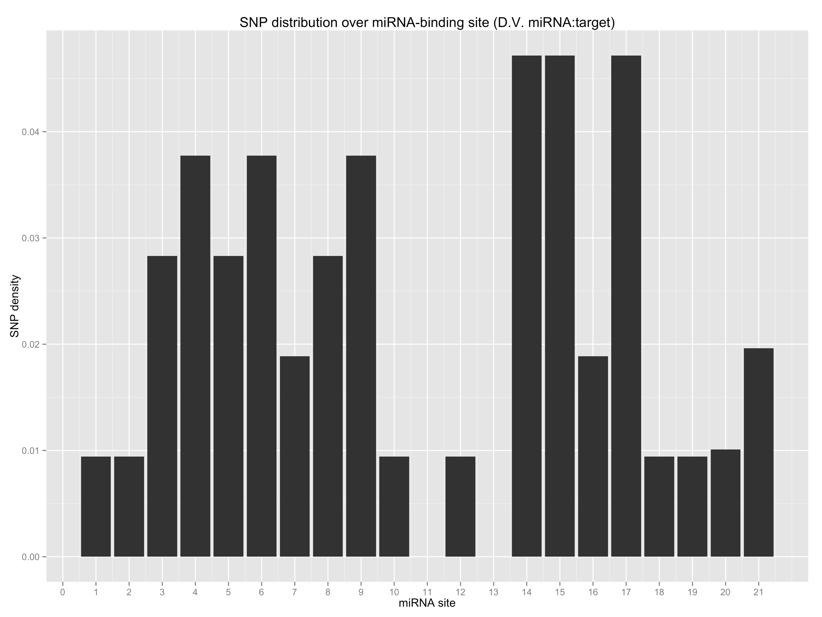

Figure 2b. (The same legend as Figure 2a)

1. **SNP density of pre-miRNAs**

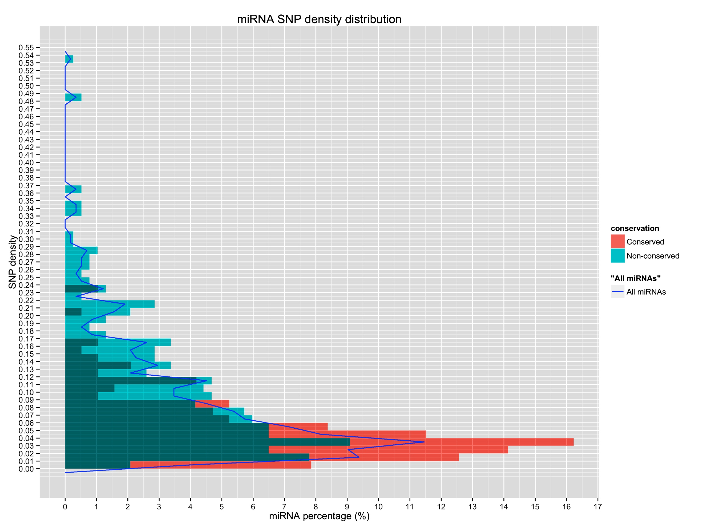

Figure 3. This is the figure of pre-miRNA SNP density distribution.

SNP density = (Number of SNPs found) / (miRNA length)

miRNA percentage = Number of miRNAs of the given SNP density / Number of miRNAs (of conserved / non-conserved / all)

Blue curve is the SNP density tendency of all miRNAs including conserved miRNAs and non-conserved miRNAs.

1. **SNP density comparison figures of pre-miRNAs with randomly chosen exons and intergenic regions**

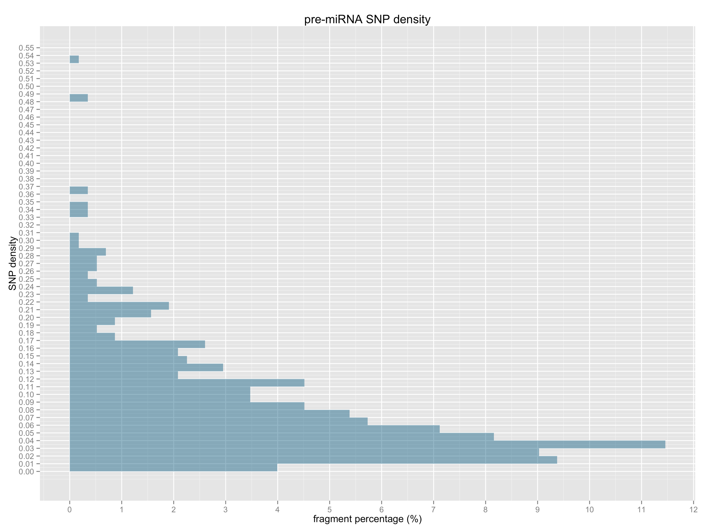

Figure 4a. SNP density of all pre-miRNAs

Fragment percentage = (Number of fragments with the given SNP density) / (Number of all fragments)

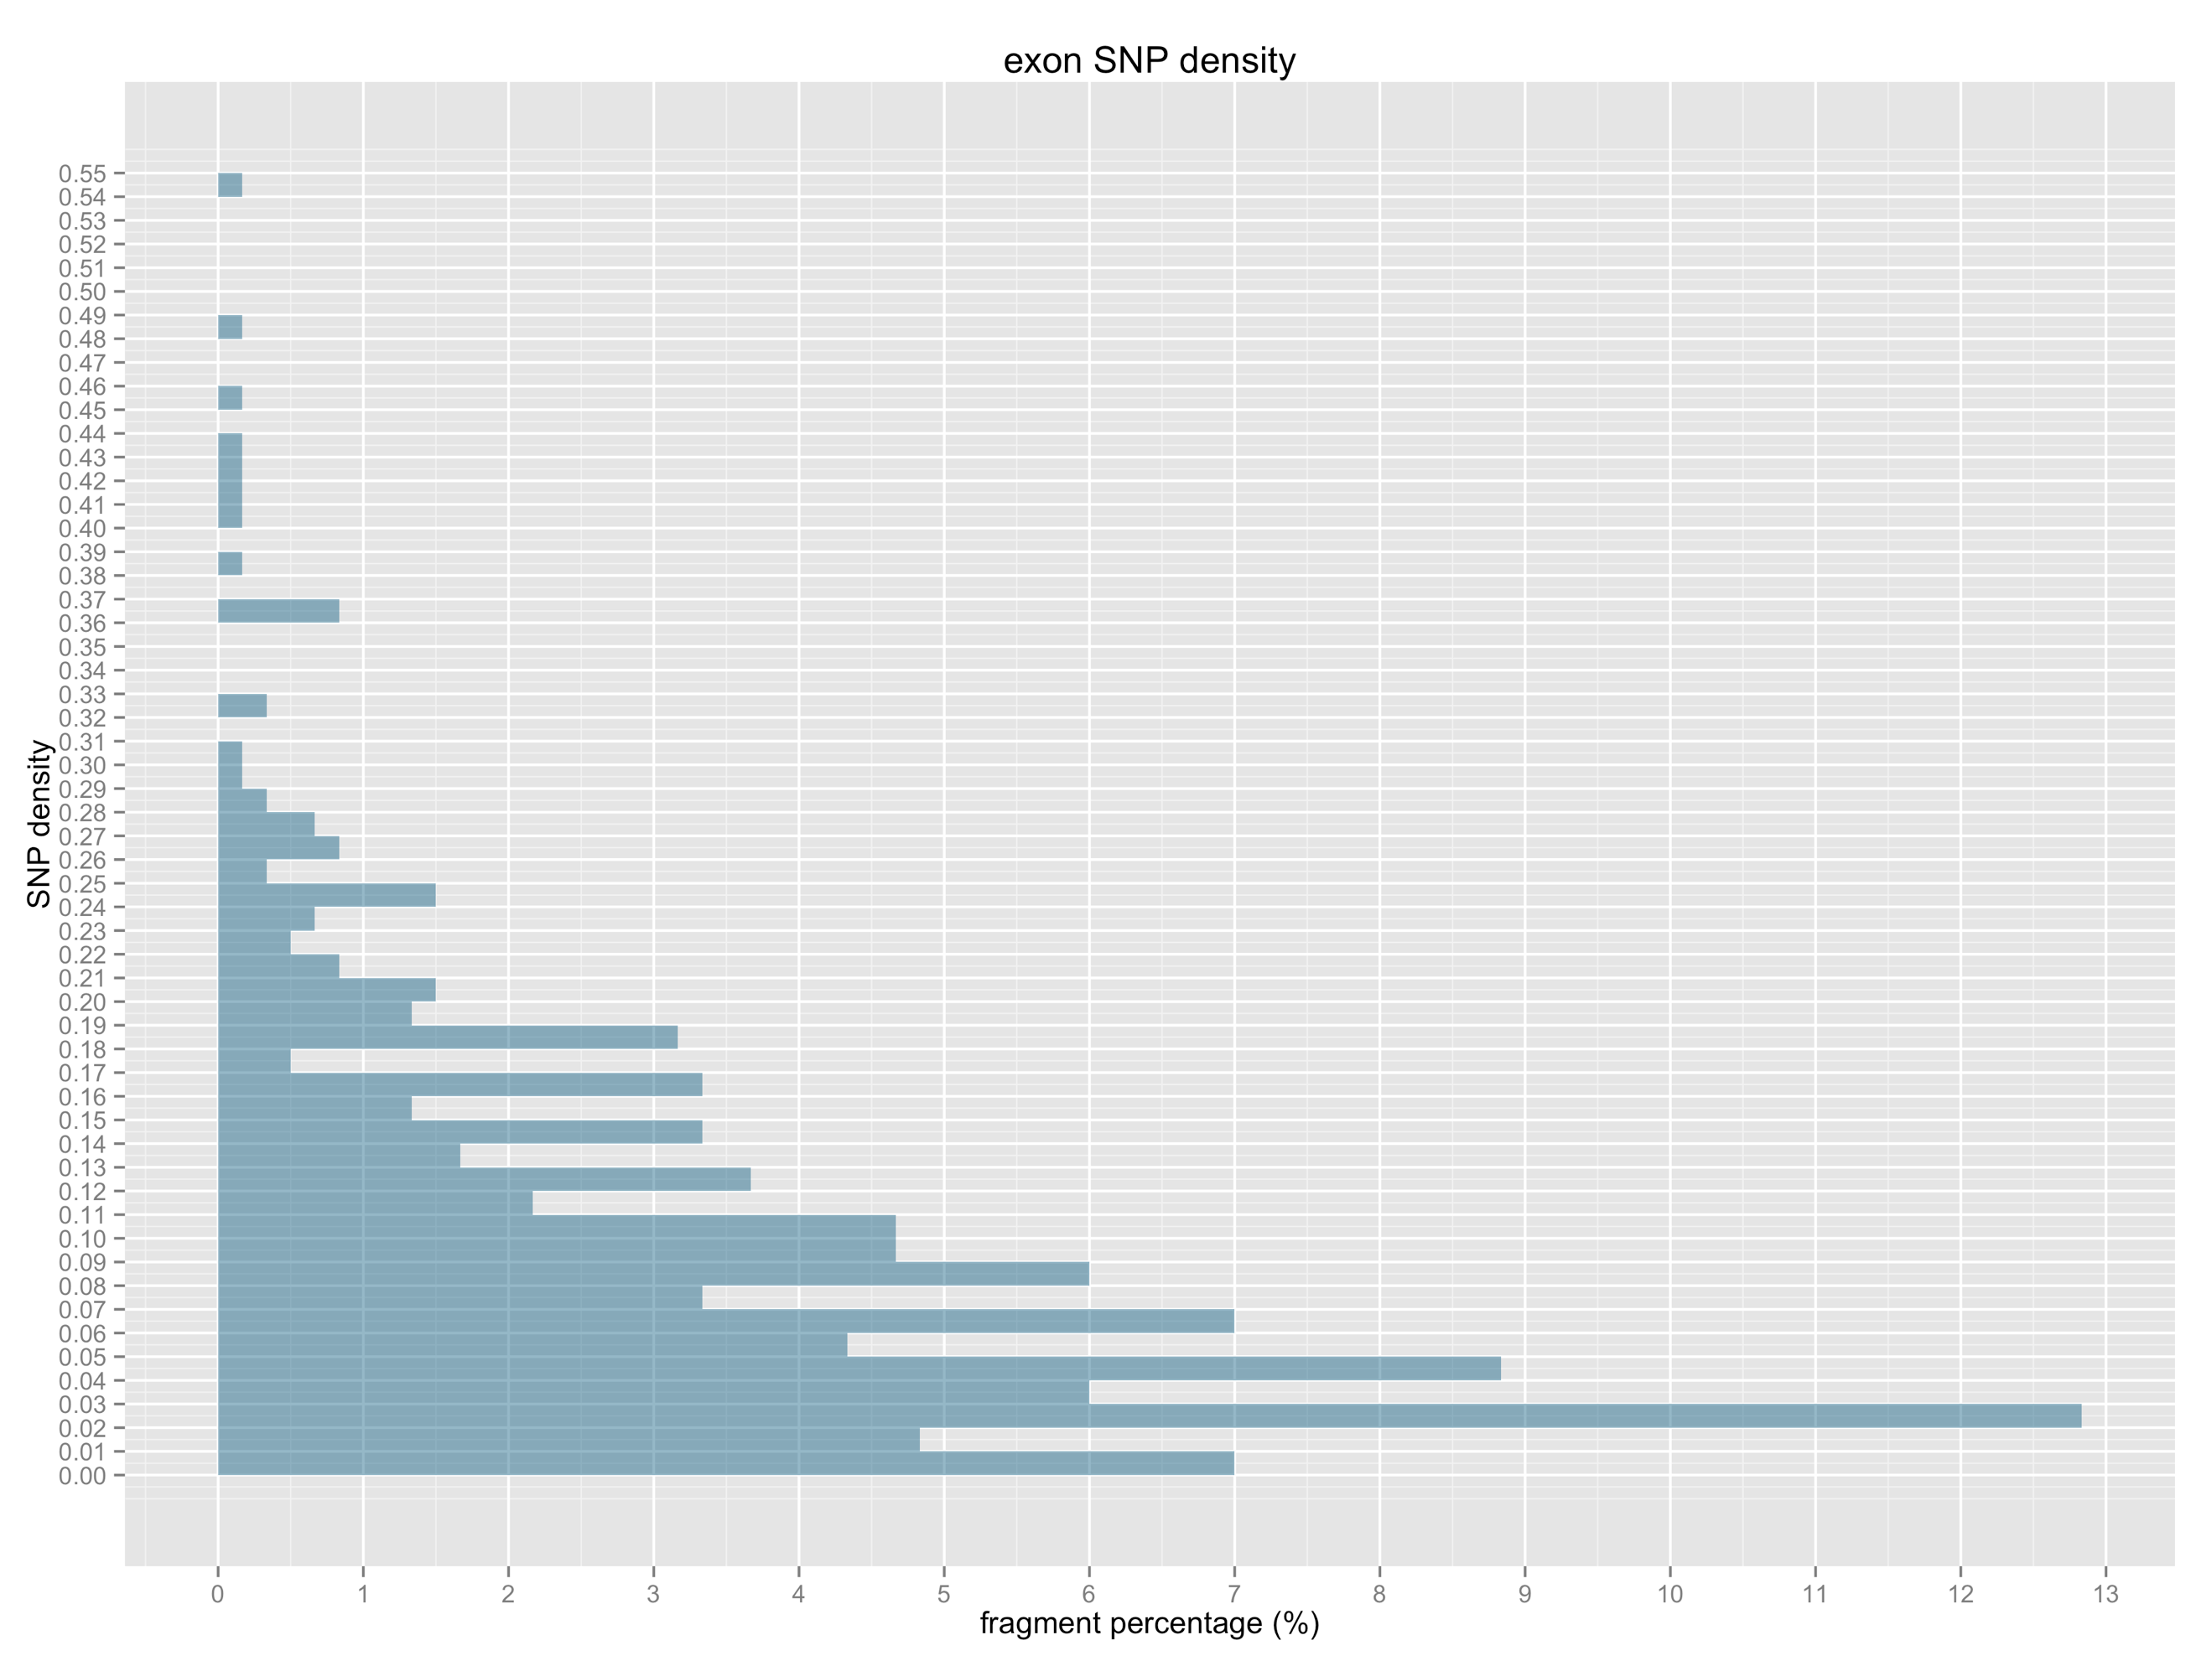

Figure 4b. SNP density of randomly chosen exon fragments.

50 fragments with the length of 150bp are randomly chosen from the exons in every of the 12 chromosomes.

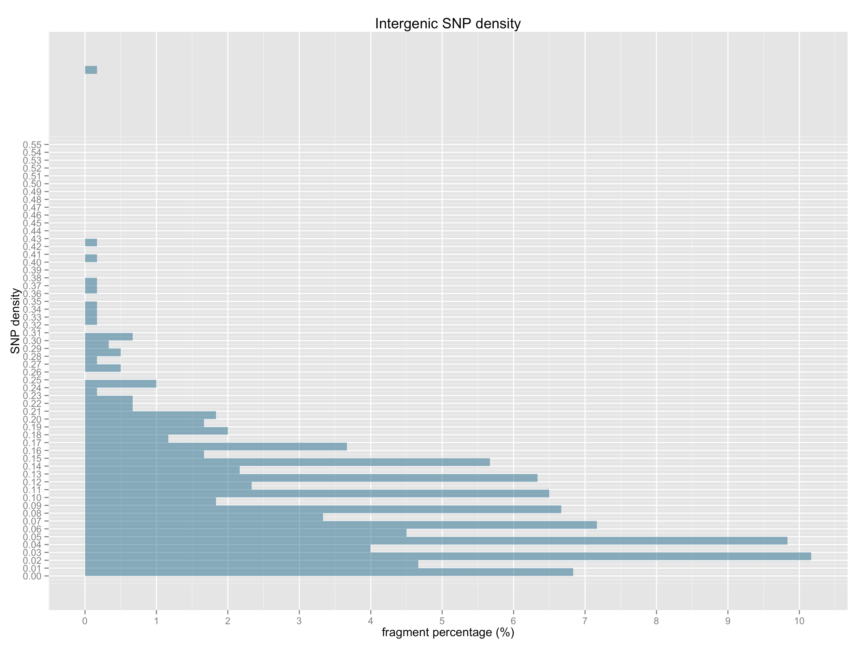

Figure 4c. SNP density of randomly chosen intergenic region’s fragments.

50 fragments with the length of 150bp are randomly chosen from the intergenic regions in every of the 12 chromosomes.